**🧩 Matillion, Made Simple**

**Tagline:** *Turn scattered data into simple, trustworthy dashboards — fast.*

**🌐 What is Matillion?**

Think of Matillion as a **bridge between raw data and useful insights**.

* Businesses generate data everywhere—sales, marketing, websites, apps, finance, customer service, etc.
* This data is usually **messy and scattered** (different formats, locations like databases, spreadsheets, APIs).
* Matillion helps **collect, clean, and organize** this data so it can be stored in a data warehouse (like Snowflake, BigQuery, Redshift) where it’s ready for analysis.

In short:  
👉 **Without Matillion** = Data is like ingredients all over the kitchen.  
👉 **With Matillion** = Ingredients are washed, chopped, and neatly placed, ready for cooking (analysis).

**🔑 Use Cases of Matillion (Explained Simply)**

1. **Marketing Analytics**
   * Marketing teams pull data from Facebook Ads, Google Analytics, LinkedIn Ads, etc.
   * Matillion combines all this into one clean dataset so they can see *“Which campaign brings the best ROI?”*.
2. **Sales Reporting**
   * Sales data may come from CRM (like Salesforce), emails, and Excel sheets.
   * Matillion integrates and transforms it into dashboards showing *monthly revenue trends, top customers, or forecast accuracy*.
3. **Finance & Compliance**
   * Finance teams need clean transaction data from multiple banks or ERP systems.
   * Matillion ensures consistent formats for *compliance reports, audits, and budgeting*.
4. **Customer 360 View**
   * A company wants to understand each customer: purchases, support tickets, website visits, product usage.
   * Matillion stitches this together into a single profile so companies can give *personalized offers*.
5. **Operational Efficiency**
   * Retailers need to track **inventory across warehouses**.
   * Matillion helps unify supply chain data so managers know *which product is running low and where to restock*.

**⚖️ How Matillion is Different From Other ETL/ELT Tools**

1. **Cloud-Native from the Start**
   * Built specifically for modern cloud data warehouses like **Snowflake, BigQuery, Redshift**.
   * Many older tools were built for on-premise databases and then adapted to cloud → less efficient.
2. **ELT (Not Just ETL)**
   * Traditional tools do heavy work outside the warehouse and then push data in (ETL).
   * Matillion uses the **power of the warehouse itself** (ELT).
   * Example: Instead of chopping veggies in your living room and carrying them to the kitchen, you just chop them directly in the kitchen (faster, fewer steps).
3. **Low-Code / No-Code Interface**
   * Business analysts (non-programmers) can drag-and-drop transformations without needing to write long code.
   * But it also allows SQL and Python for advanced users.
4. **Scalability & Speed**
   * Since it leverages the warehouse, you can process **billions of records in minutes**, which many legacy ETL tools struggle with.
5. **Cost-Effective**
   * Runs inside your existing cloud infrastructure, so you don’t need huge separate servers.
   * Pay for what you use, unlike older ETL tools with expensive upfront licensing.

✅ **In short**:

* **Informatica / Talend / SSIS** = Traditional, heavy, on-prem or hybrid ETL.
* **Matillion** = Agile, cloud-first, scalable, easier to use.

**🍳 The Kitchen Analogy**

**Goal:** Serve great “insights” (meals) to leaders.

* **Ingredients** = Raw data (sales, ads, website, app, support)
* **Pantry** = Cloud data warehouse (Snowflake, BigQuery, Redshift)
* **Chef** = Matillion
* **Recipe steps** = Data transformations (clean, join, calculate)

Without Matillion: ingredients everywhere, recipes unclear, slow cooking.

With Matillion: chef works *inside* the kitchen (warehouse), follows drag‑and‑drop recipes, meals come out faster and consistent.

**🔄 ETL vs ELT — What’s the Difference?**

**ETL (Extract → Transform → Load)**

* **Where it cooks:** Outside the data warehouse on a separate server/tool.
* **Flow:** Pull data → **reshape outside** → push final tables into warehouse.
* **When it’s okay:** Smaller volumes, legacy systems, strict on‑prem rules.
* **Limits:** Extra servers to manage, slower at scale, harder to change.

**ELT (Extract → Load → Transform) — Matillion’s sweet spot**

* **Where it cooks:** *Inside* the warehouse (use its horsepower).
* **Flow:** Pull data → **load raw** into warehouse → transform there.
* **Why it’s better now:** Warehouses are fast & cheap to scale; you avoid bottlenecks.
* **Benefits:** Quicker builds, simpler ops, better for big data.

**Plain‑English analogy:**

* **ETL:** Chop veggies in the living room, then carry them to the kitchen to cook.
* **ELT:** Take the veggies to the kitchen first, and do all the prep + cooking there. ✅

**🛠️ What Matillion Does (in human words)**

* **Connects** to data sources (Salesforce, Facebook/Google Ads, databases, CSVs, APIs)
* **Cleans & combines** with drag‑and‑drop “components” (no heavy coding needed)
* **Schedules** automated runs (hourly/daily) so dashboards are always fresh
* **Orchestrates** end‑to‑end pipelines (load, transform, quality checks, alerts)

**📦 Common Use Cases (Non‑Tech Friendly)**

1. **Marketing ROI in one place**
   * Combine Facebook, Google, LinkedIn, CRM → See CAC, ROAS, top campaigns.
2. **Sales performance**
   * Merge CRM + billing → Track pipeline → revenue → churn with one truth.
3. **Finance & compliance**
   * Standardize transactions across ERPs/banks → automated close & audit packs.
4. **Customer 360**
   * Stitch product usage + support + purchases → personalize offers & retention.
5. **Retail operations**
   * Unify inventory & orders → alert on stock‑outs → optimize replenishment.
6. **Executive dashboards**
   * Clean, consistent metrics (MRR, NPS, LTV) refreshed nightly.

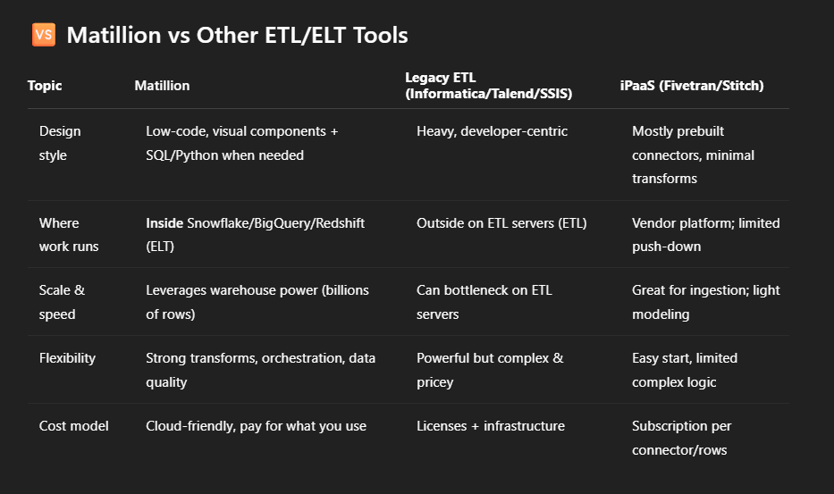

**TL;DR:**

* If you want **modern analytics on Snowflake/BigQuery/Redshift**, with **low‑code** builds and **serious transformations**, Matillion is a great fit.
* If you only need **raw ingestion** with minimal logic, iPaaS may suffice.
* If you’re stuck on **on‑premise/legacy**, traditional ETL might still be required.

**🧭 When to Choose Matillion**

* Your data lives (or will live) in **Snowflake/BigQuery/Redshift**.
* You want **fast delivery** with **drag‑and‑drop** builds but developer power when needed.
* You expect **data volume growth** and want **simple scaling** (no extra servers).
* You need **governed, repeatable pipelines** with monitoring & alerts.

**🧪 Mini Storyboard (1‑Minute Pitch)**

1. *We collect data from tools we already use.*
2. *Matillion loads it into Snowflake as‑is (raw).*
3. *Inside Snowflake, Matillion cleans and combines it into business‑friendly tables.*
4. *Power BI/Tableau dashboards update automatically every morning.*
5. *Leaders trust the numbers because the recipe is versioned, tested, and auditable.*

**🗣️ Speaking Notes (for Non‑Tech Audiences)**

* “Think of Matillion as our **data chef**. It works **inside our kitchen** (Snowflake) so meals (dashboards) are fast and consistent.”
* “**ELT** is modern because we use the **warehouse’s horsepower** rather than buying extra servers.”
* “This reduces **cost & complexity**, speeds up delivery, and scales with our growth.”

**✅ Quick Checklist (Decision Guide)**

* Using Snowflake/BigQuery/Redshift today or soon? → **Yes → Matillion fits**
* Need complex joins/logic beyond simple copying? → **Yes → Matillion**
* Want analysts building pipelines without deep code? → **Yes → Matillion**